PROOF OF CONCEPT FOR Dr. Fix Mypain

By Phatutshedzo Makushu

Target audience:

* Existing patients
* New patients

THE PROBLEM

* Existing patients are facing problems when it comes to booking appointments.
* New patients face problems when it comes to booking appointments.
* Patients have to call receptionist so as to book appointments.
* Patients have to physically be present at the surgery so as to book appointments.
* Patients can only book appointments during working hours.
* The patients’ phone calls are put on hold most of the time.
* There is only one receptionist.
* The receptionist works from 8.30 to 17.30 every day.
* There are double bookings.
* Cancelling appointments is time consuming.
* Rescheduling appointments is time consuming.

FEEDBACK FROM THE USERS

* 20 users were interviewed.
* 50% of the users were new users.
* 10% of the existing users make telephonic appointments.
* 17 users did not like booking face to face.

SOLUTION

* A web application that will allow both existing and new users to book appointments online.
* Both existing and new patients to be able to make appointments in the comfort of their homes.
* Patients will be able to book appointments on any Internet connected device.
* When a new user registers, they have to provide full names, cell number, email address and password.
* The cell number and email will be used to automatically send reminders to the patients about their appointment times and dates.
* The email will be used to make the patients to be able to put the appointment on their Google, Yahoo and/or other calendars.
* When users log in, past and future appointments are displayed.
* The reasons for the appointments are also displayed.
* The user can only reschedule or cancel future appointments.
* When booking for appointments, the calendar automatically updates to make it possible for patients to book for that day until two weeks from then.
* Users will be able to update their details like password or cell number.
* Dr. Fix Mypain will be able to view all the appointments on any Internet connected device.
* Dr. Fix Mypain will be able to update the patients’ diagnoses which he alone can view and edit.
* Dr. Fix Mypain will be able to get automated emails if a patient reschedules or cancels an appointment.
* Sessions will be set to five minutes.
* Cookies will be there to allow users to easily log in.
* Online payment will be made available.

TECHNOLOGIES TO BE USED

* HTML
* CSS
* PHP
* MySql

COSTS TO BUILD THE SOLUTION

|  |  |
| --- | --- |
| ITEMS | ESTIMATED COSTS |
| Operational Costs |  |
| Laptop | R20000 |
| System hardware | R17000 |
| Web-based Research and Books | R15000 |
| Travelling and consultations | R32700 |
|  |  |
| **Sub-Total** | **R84700** |
|  |  |
| Consumables |  |
| Stationary | R12200 |
| **Sub-Total** | **R12200** |
| **GRAND TOTAL** | **R96900** |
|  |  |

SYSTEM TESTING

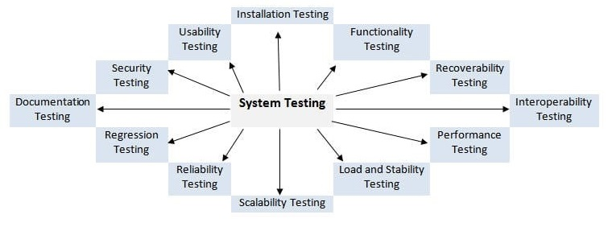

There will be twelve stages of system testing:

* Functionality testing will be done in order to see how the system functions.
* Recoverability testing will be done so that if the system malfunctions then there will be a way to put it back to work as soon as possible.
* Interoperability testing will be performed to see if the system can operate in different environments along with other systems.
* Performance testing will be done to evaluate how the system performs different tasks that it is supposed to perform.
* Load and stability testing will be done so that we can see how stable the system can be.
* Scalability testing will be performed in order to see if the system will be able to handle a growing amount of work.
* Reliability testing will be done to see if the system will output the correct results as well as perform at the same pace as always.
* Regression testing will be measured so that the relation between the mean value of one variable and the corresponding values of the other variables will be checked.
* Documentation testing will be done so as to see if the written words correspond to the functionality of the presented system.
* Security testing will be performed in order to see if there are ways to combat any kind of attacks that may happen in future.
* Usability testing will be made to see if users are able to use the system and are comfortable with using it. Installation testing will be done so as to see how the system will operate on different environments.

SYSTEM IMPLEMENTATION

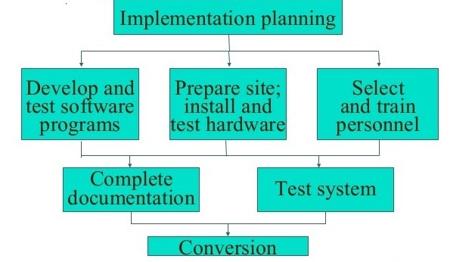

* The system will be developed and tested by a number of people so that feedback can be given.
* The feedback will be used to improve the system in every possible way.
* Once the system is fully completed, people are going to be trained on how to use it efficiently.
* Documentation will then be completed in order to have reference on how the system was made and how it works.
* It will help with future improvements.

DELIVERY TIME

* It will take 6 months to have a fully functioning, efficient and fast online booking web application.